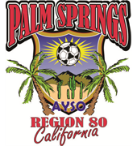
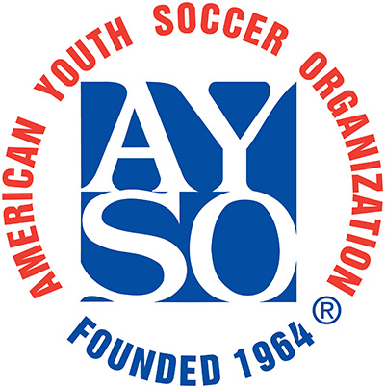

AYSO Region 80 is a nationwide non-profit organization founded in 1964 to bring soccer to communities. We are an all-volunteer organization, from our coaches to our referees, to our board members. AYSO develops and delivers quality youth soccer programs in a fun, family environment based on AYSO’s Six Philosophies: Everyone Plays, Balanced Teams, Open Registration, Positive Coaching, Good Sportsmanship, Player Development.

It takes all of our support to have a successful soccer club in our community. Our program is strictly funded through player registrations and the generous donations of our local businesses. By sponsoring a team you will assist the club in the purchase of needed equipment, help pay fees for field use, promote youth soccer and advertise your business. On average AYSO Region 80 has over 500 players yearly.

SPONSORSHIP LEVELS
GOLD: $1000
- TEAM PHOTO
- WEB LISTING - LINK
- TEAM SPONSORED PLAYER T-SHIRTS
- 3x8 FT FULL COLOR BANNER
- SPONSOR AD ON WEBSITE

SILVER: $500
- TEAM PHOTO
- WEB LISTING - LINK
- 3x6 FT BANNER
- TEAM SPONSORED PLAYER T-SHIRTS

BRONZE: $350
- TEAM PHOTO
- WEB LISTING - LINK
- TEAM SPONSORED PLAYER T-SHIRTS

Thank you,
David Darrin
Sponsor Coordinator
daviddarrin@dc.rr.com
(760) 320-7161
801 E. Taqhuitz Canyon Way #100 Palm Springs, CA 92263

Make Check Payable to: AYSO REGION 80
SPONSOR LEVEL: ______________________ SPONSOR NAME:_______________________________
ADDRESS: ______________________________________________________________________________
PHONE: ________________________________ EMAIL: ________________________________________
TEAM NAME/PLAYER (Optional): __________________________________________________________

AYSO is a nonprofit tax-exempt corporation registered with the United States Internal Revenue Service and the California Franchise Tax Board. Our tax-exempt is determined by section 501C(3) of the United States Internal Revenue Code AYSO FEDERAL I.D. #95-6205398

